Heritage Centre Visit March 14th 2023
 | Building a canal  - We learnt about Navvies.  - We learnt what the canals were lined with, and where water was sourced from.  - We noticed what changed around the canals and how their use changed with time.  - We talked about what pulled the boats and what they walked on.  - We learnt about the invention of the combustion engine and how railways replaced the canal network. | 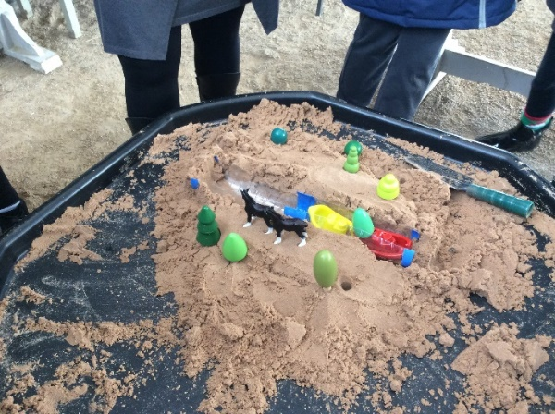
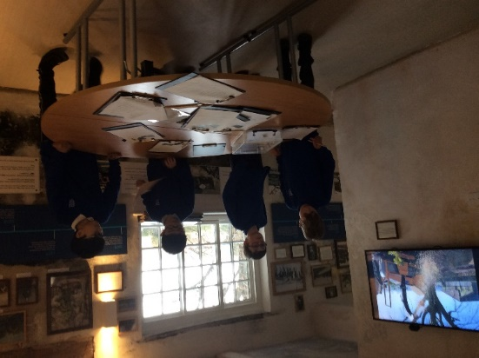 | Researching Beeson’s canals  - We learnt about Bargees.  - We used different sources to learn about Beeston Rylands in the past.  - We used the timeline and photos to answer questions.  - We all visited the cottage that has been left as it was used.
Learning about life on a narrow boat

- We made a space 2m by 2.5m to understand what the cabin size was for families working on the canal.
- We learnt about what possessions would have been available to those families.
- We compared this to what we would expect to have on a holiday in the present day!

