Acorn Newsletter
This week at Nursery
This week, we have been reading the story ‘The Train Ride’ and we’ve been thinking about methods of transport we could use in Beeston. Peppa Pig would like to visit us, so we’ve been telling her all about the special places in our community.
On Friday we enjoyed making our own hot air balloons. We experimented by blowing up a normal balloon and finding ways of lifting it into the air. We discovered that by using a tunnel and a hairdryer it went higher than just using our breath.
We really enjoyed setting up a shop in our classroom and Beeston Train Station outside in our playground. We’ve enjoyed lots of imaginary journeys and pretending to shop in Tesco’s.
Last week was Chinese New Year and this year is the year of the rabbit. We loved learning the river race story and how the animals won their place in the Chinese Zodiac calendar. We also performed a dragon dance around school with instruments and ribbons.

Songs for this week:
Down by the station: https://www.youtube.com/watch?v=QP-270x7U-A
What makes 4 song: https://www.youtube.com/watch?v=HzlfPXwy1YY

Diwali
Triangle song

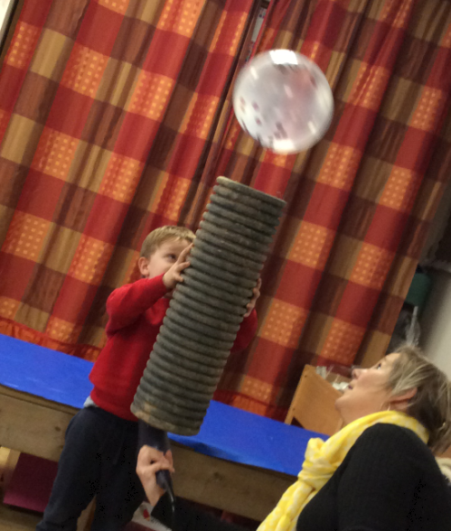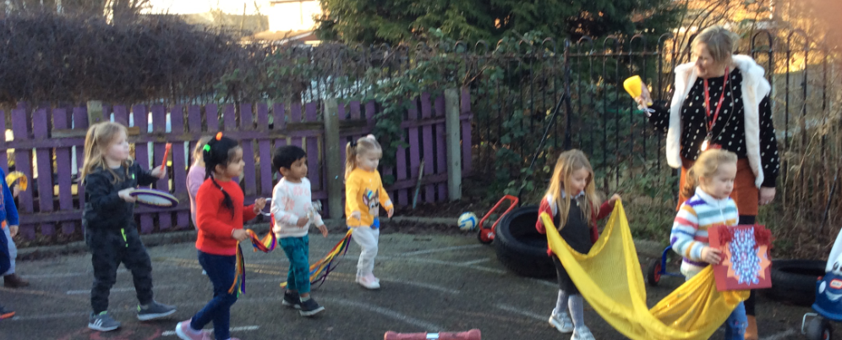

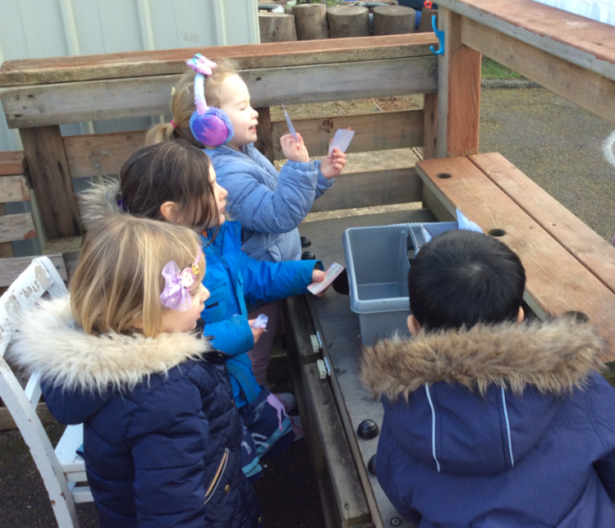
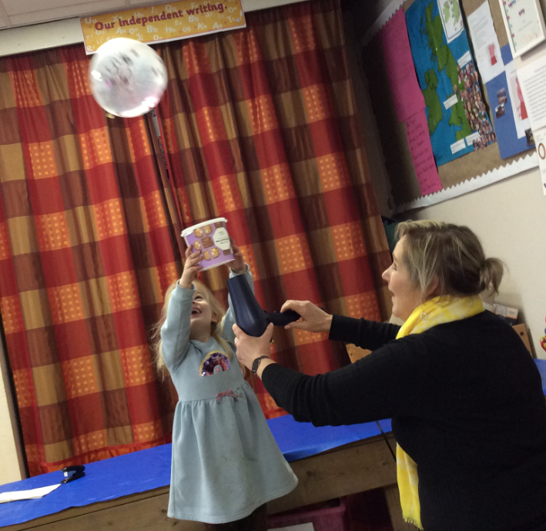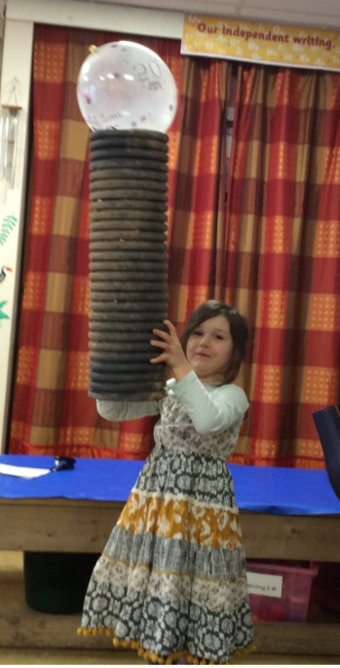
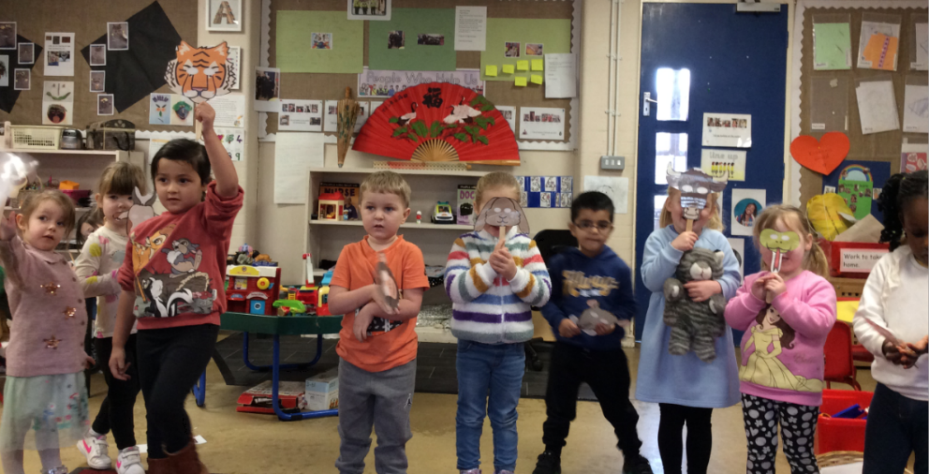
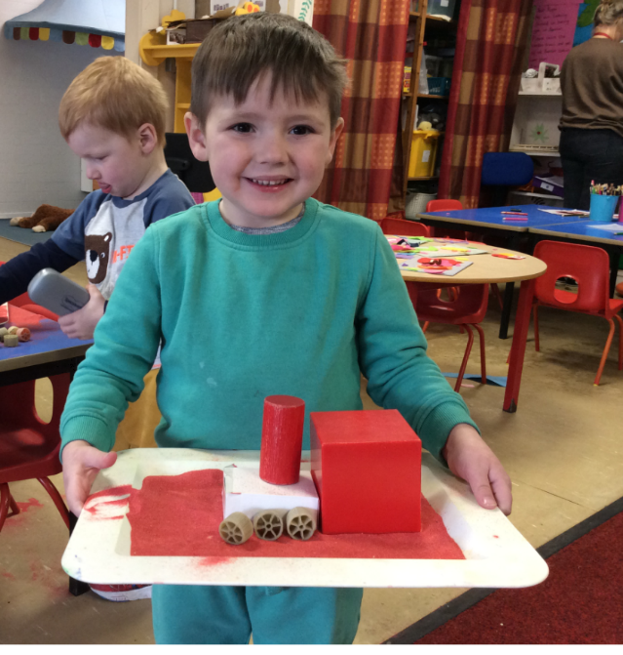
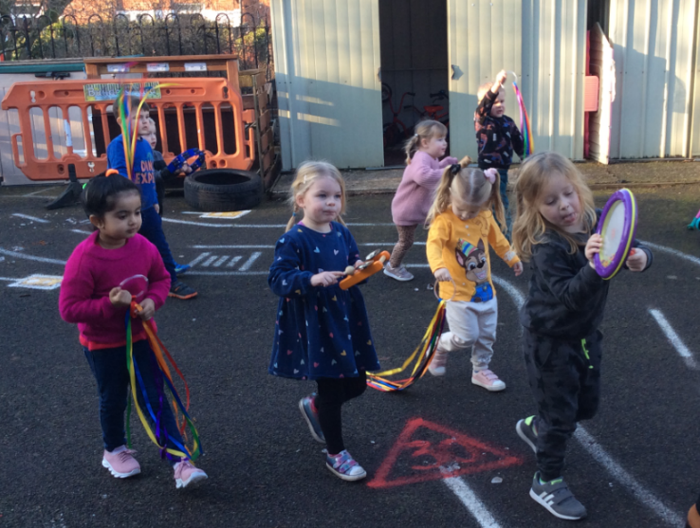
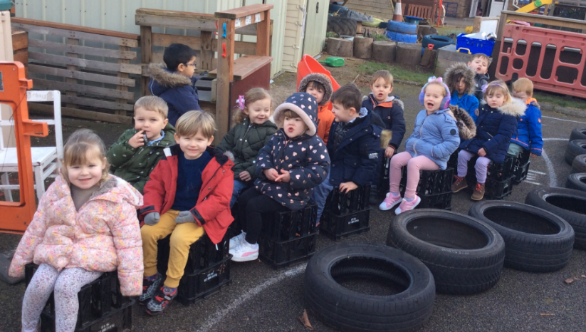
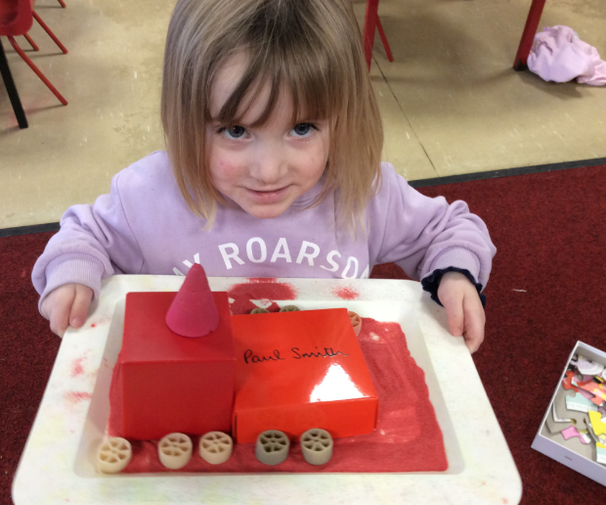
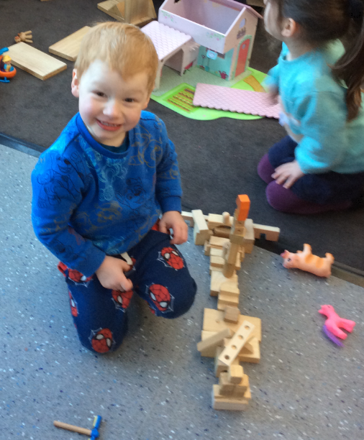

In maths this week, we have looked at patterns & pictures showing the amount 4. We have rearranged objects to show that this amount won’t always look the same. This has also helped us to visualise how the amount 4 can be made up of different amounts, such as 2, 1 and 1 etc.
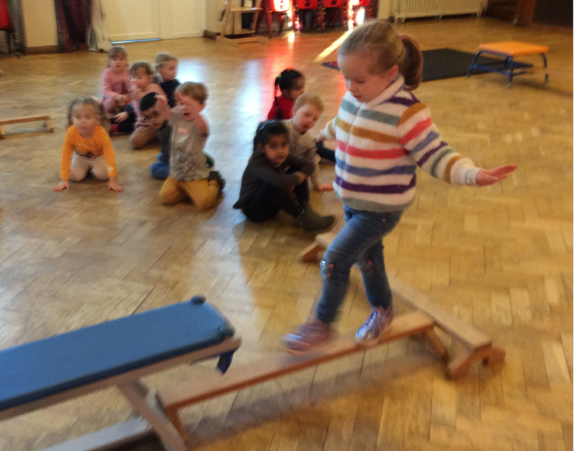
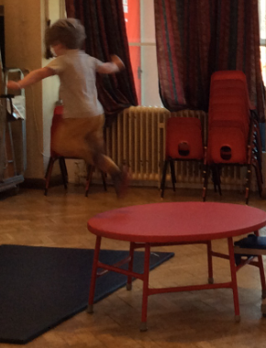
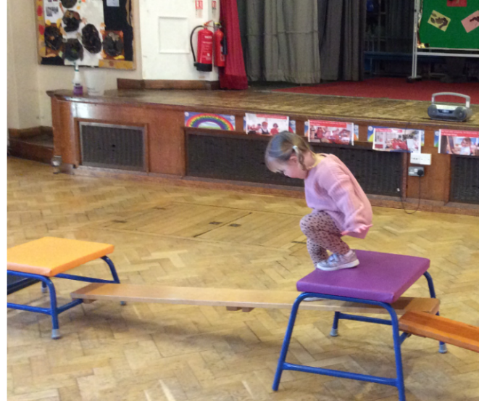
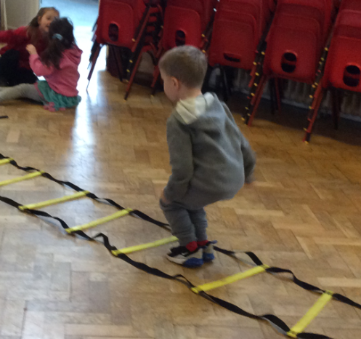

In PE we have been practising our gymnastic skills, balancing, climbing and jumping safely.

Thank you for the brilliant support again this week during our focussed activities. Next week our themes will be number writing. Name writing and an instructions game again.
Monday. Name writing.
Wednesday: instructions game.
Friday : number writing.
Have a lovely weekend everyone.
Mrs Welbourn, Mrs Walker, Miss Elliott and Mrs Ellis

