Maple and Elm Parent Information Letter Spring 1 2022
Geography This half term we will be looking at human and physical features. We will then learn about maps and create our own map. We will use beebots to understand directions and also learn about coordinates.

R.E. This half term we will be looking at features of the church, what a church is and symbols that can be found in a church. We will also visit a church as part of this topic.
Literacy
We will be focusing on a book this half term related to our topic of traditional tales. We will spend lots of time reading the book together, completing many activities to develop our understanding of new vocabulary and the themes within the story.
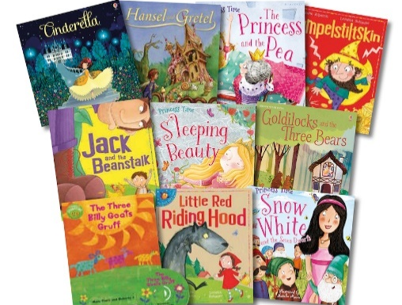
Once Upon A Time

D&T
This half term we will be looking at textiles. We will be making a hand/finger puppet. We will be joining felt together using stitching.
ICT
We will continue to follow the ‘Purple Mash’ scheme of work. We will be looking at the module ‘Lego builders’. This will include following instructions; knowing that an algorithm is a precise, step-by-step set of instructions. used to solve a problem or achieve an objective.

P.H.S.E
This half term the theme is ‘Dreams and Goals’.
We follow the ‘JIGSAW’ scheme and will look at our strengths and achievements and discussing how these make us feel. We will also think about how our strengths make us a good learner. We will think about working together in groups and how we can do this well.

PE We will be developing our skills in Basketball.

Numeracy
We will be ordering, comparing and estimating numbers to 20. Alongside one more and one less and problem solving.

