How Maths is taught in Nursery

The following skills are run throughout the year-

Daily Skills
Maths taught throughout the day.
The following is used to support maths teaching:

• Days of the week song and talking about the day
• General counting e.g. counting how many bananas there are in the fruit box.
• Counting songs
• Use of ordinal numbers e.g. “Sam line up first, Lilly line up second…”
• Maths games such as track counting games
• Noticing maths in the environment e.g. asking children what they notice about a tree. They may say it is tall, has circles on etc.
• Incorporating maths in areas of continuous provision wherever possible e.g. an activity that matches numeral to quantity in the finger gym area.
• Incorporating maths in daily routines e.g. during registration time. If there are 3 children absent the children clap 3 times. Having labels on pencil pots with a representation of a number to show how many pencils go in that pot during tidy up time. Different representations of number on the ‘how many children can play here’ posters

The following representations are used to support our learning:
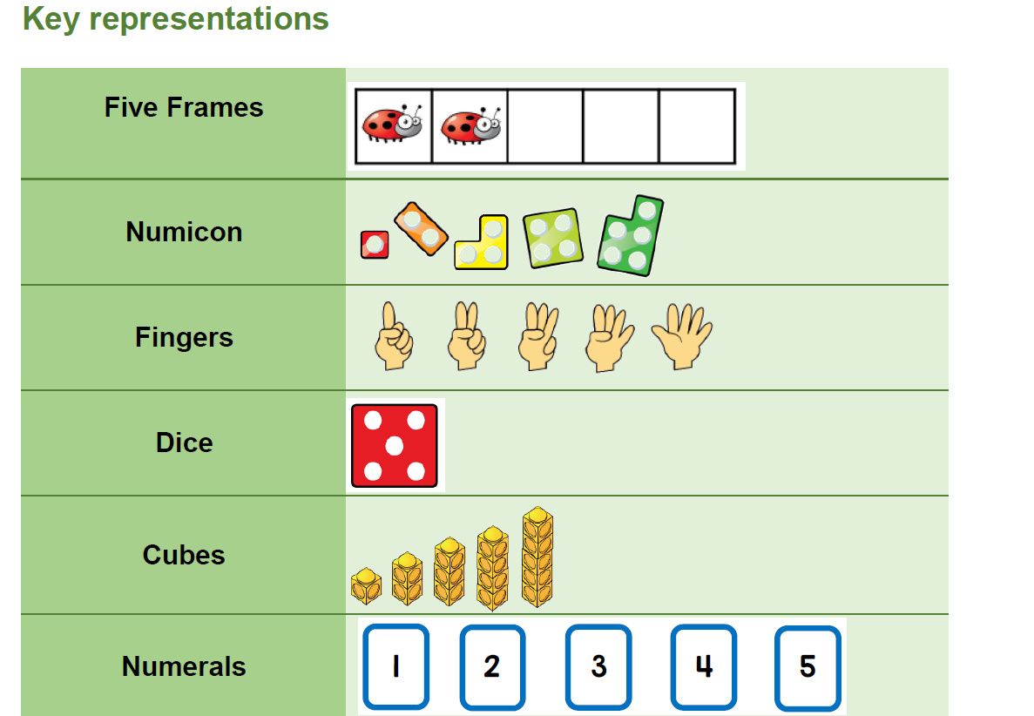
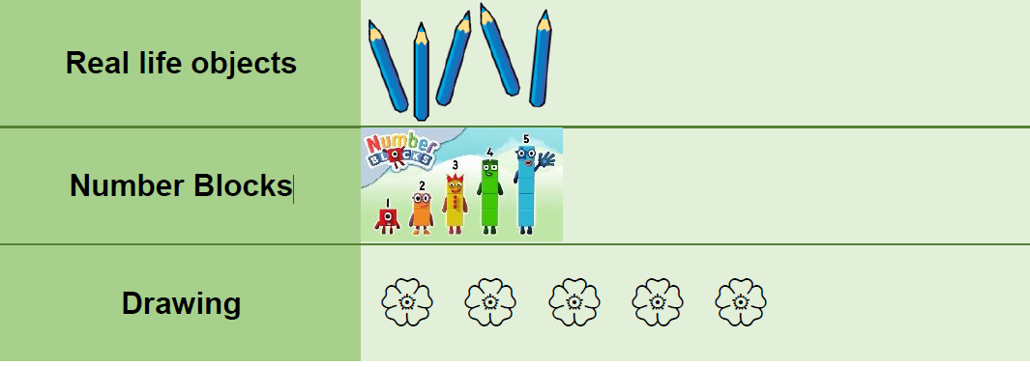

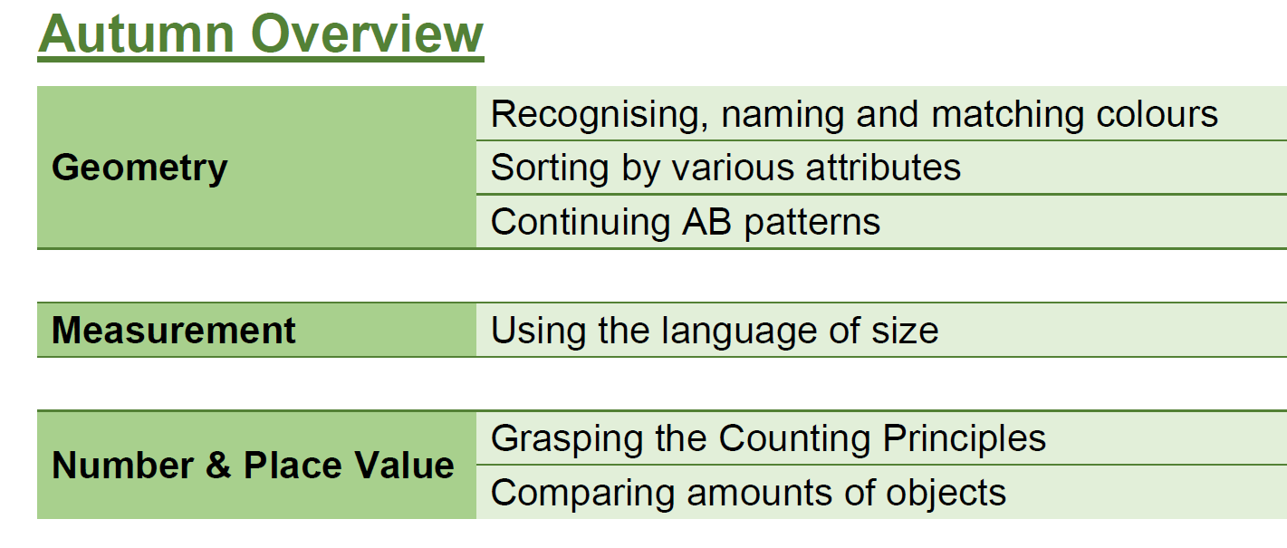
Key vocabulary

Notice, match, same, colour

Sorting
There will be a focus on reasoning within sorting e.g how have you sorted the buttons?
There will be opportunities for the children to sort objects by their own rules.
This will be explored in various ways such as shape, colour and size.
Children will be taught to verbalise what is the same and what is different.

Key vocabulary
Sort, notice, groups, sets, same, different

Pattern-
Developing an awareness of pattern helps children to notice and understand mathematical relationships.
Children will inititally be taught to continue AB patterns.
Children will be given the opportunity to recognise patterns and continue it.

Size-
This term will be focusing on large/ big and small/little.
Real life objects will be incorporated in order to compare.
We will use sentences such as ‘The ________ is smaller / larger than the_____________’.

Comparing-
Children will be given opportunities to compare collections of objects and which groups have more things.
Children will be encouraged to count from left to right.
We will use the language ‘more or fewer’.

SPRING TERM:
Numbers 1/2/3
We will incorporate real-life objects to count.
We will start by counting objects that are identical before moving on to different objects.
Children will be encouraged to put objects into a line in order to count them, this will help to identify a clear start and end.
Five frames can be used to place objects clearly.

For example:
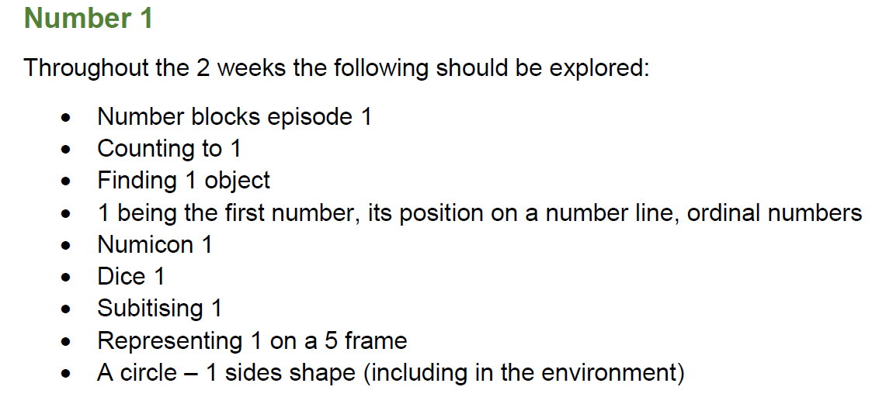
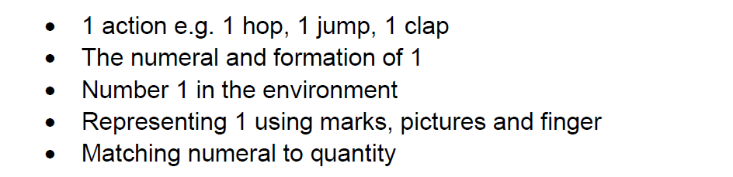

SPRING 2
NUMBERS 4 / 5 / 6
Key vocabulary
Number, numeral, how many, count, first, second, third

SUMMER TERM

SHAPE / MEASURE / POSITIONAL LANGUAGE
Summer 1
Shape
We will look at the properties of shape.
Children will be encouraged to look and describe shapes in their environment.
Again, real-life objects will be incorporated.

My Day

Children will be encouraged to talk about and order the events of their day e.g waking up, going to nursery, bed time.
Key vocabulary
First, next, then, last

Length and Height
Children will be encouraged to apply the attributes long, short, tall etc to verious objects.
Children will use such language as taller than/ shorter than.

Summer 2
Weight, capacity, positional language

Weight
Initially, we will begin with identifying objects we think may be heavy.
Then, we will move onto comparing weights.
Capacity
Children will be encouraged to recognise when a container is empty / full.
We will then move onto talking about different sized containers.
We will also look at which container will hold more or less via pouring.

Positional language
Children will be given the opportunities to use the language of position and direction i.e under, up, down
We will also cover ‘in front of or behind’ this could be done via creating maps.

